Name : ___________________________ Date : _________________

Jeroo Basics Worksheet

- How many Jeroos can you create in 1 program?

Four jeroos

2. What is the one method you MUST have in your program?

Method Main

3. Write the code to create a new Jeroo named neo.

Jeroo neo = new Jeroo();

4. Write the code to make neo hop one space forward.

neo.hop();

5. Write the code to make neo turn right.

neo.turn(RIGHT);

6. Write the code to make neo hop forward 5 times .

neo.hop(5);

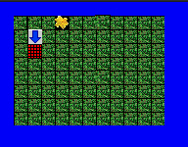

7. Knowing the way maps are ordinarily represented, what direction would you say Nelson is facing?

South

8. What is the exact location of the flower?

(0,3)

9. Where is the net?

(2,1)

10. What is Nelson’s location ?

(1,1)

